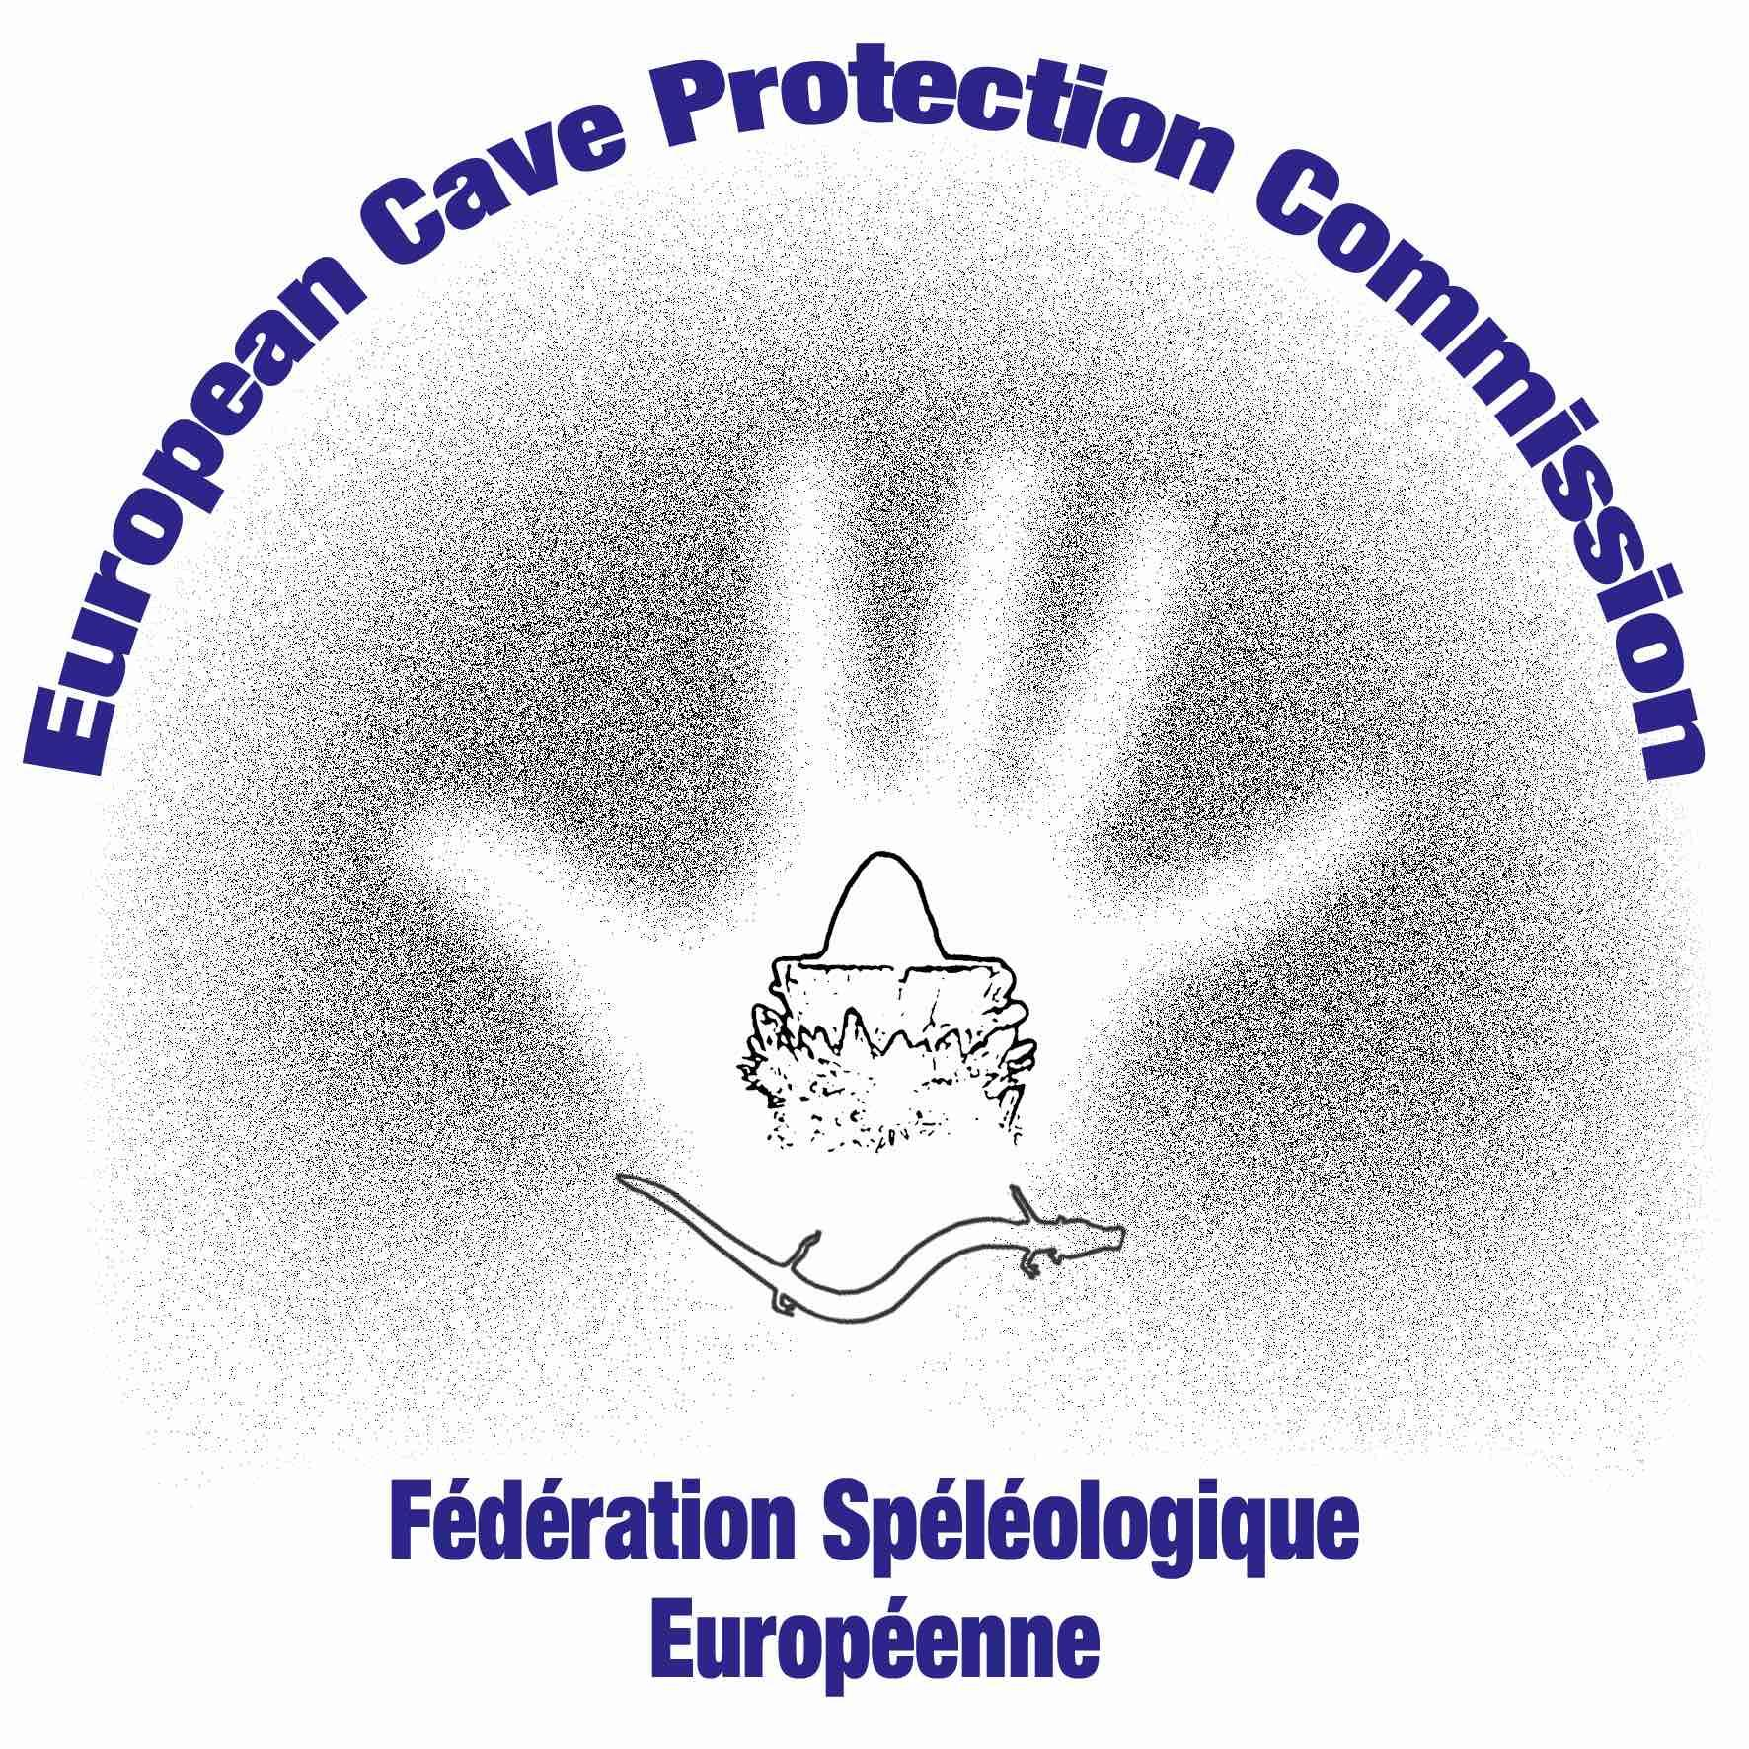
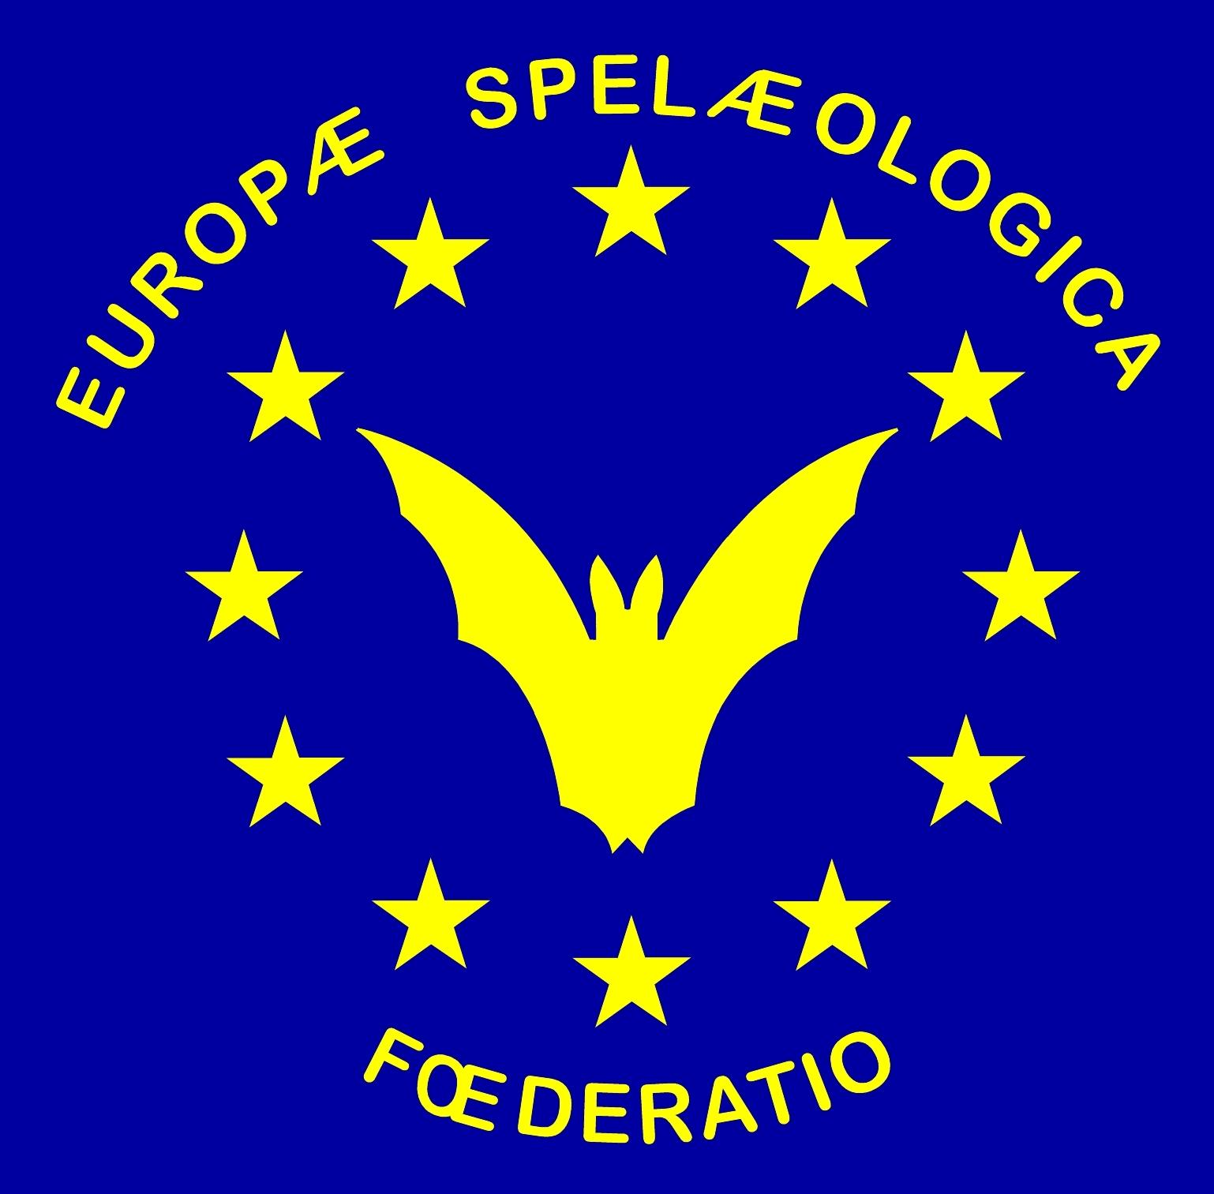

FEDERATION SPELEOLOGIQUE EUROPEENNE
European Cave Protection Commission

Clean Up the Dark European Network
Clean Up the Dark National Report

Ref.FSE/ECPC/Clean Up The Dark

Preamble
“Clean-up the World”, is the largest environmental volunteer event in the World and the Italian Speleological Society (SSI) represents the national organization for the clean-up cave chapter: Puliamo il Buio. Since 2005 it acts thanks to the helpful support of hundreds of cavers. SSI coordinates the event at local level in partnership with caving clubs, associations, companies, local authorities and municipalities. How does this work in other countries in Europe? We are working on a research on the past and actual de-pollution activities in caves in European countries and a proposal of a Clean Up the Dark European Network for the communication and coordination of cave cleaning and cave protection, and so pushing the European speleological community to take more action for cave protection and became a stronger stakeholder in relation with EU and national institutions and the general public.

Within the European continent, we can see that in a lot of countries a certain number of polluted caves have been cleaned. In the past it consisted of merely sporadic, isolated and local initiatives with no centralized coordination nor reporting system. In the last 10-15 years however, there is a trend towards a more organized approach. In Italy, Croatia, and Switzerland there already exists a national yearly karst clean-up and protection project. However, approaches differ between countries, but karst and water know no boundaries invented by mankind.

Through a European network we can merge these different approaches into a centralized platform that will guide each country with all the necessary information and support and is motivating and supporting other countries not yet active in de-pollution initiatives.

As a matter of fact the ECPC (the European Cave Protection Commission of the FSE) is promoting Cave Protection at the European scale since its foundation and is supporting the Clean Up the Dark European Network initiative that will be presented at the 13th EuroSpeleo Forum 2019 in Sofia (BG).

Data sheet Clean Up the Dark 2019

Does your country or region have a clean-up and protection project? Do you have done cleaning caves action in the past year? Please pass us the info below:

Country Name: ………………………………………………………………………………………………………........

Delegate reporting: ………………………………………………………………………………………………………..

Number of caves registered: ………………………………………………………………………………………….

Number of caves polluted or contaminated: ………………………………………………………………….

Name and acronym of the project/initiative: ……………………………………………………..........................….

Leader Organization (Name, Country, Contact): …………………………………………………………….
…………………………………………………………………………………………………………
…………………………………………………………………………………………………………

Person in charge of the project/initiative (Name, e-mail, telephone):
…………………………………………………………………………………………………………

Place of project implementation:
…………………………………………………………………………………………………………

Key Dates of the cleaning or protection initiative:
…………………………………………………………………………………………………………
…………………………………………………………………………………………………………

Small Description of the project /initiative:
........................................................................................................................
........................................................................................................................
........................................................................................................................
........................................................................................................................
........................................................................................................................

Form to be sent by e-mail to Clean Up the Dark European Network, (cleanupthedark@socissi.it) before the 15th of September 2019.

