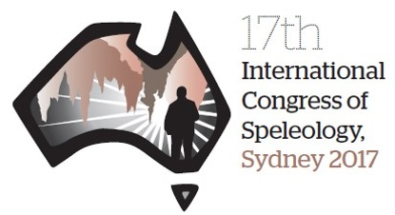
Dear all,

Apologies for any cross posting.

Please be reminded the 17th International Congress of Speleology (17th ICS) of the UIS is being held in Australia (Penrith, western Sydney), 23 – 29 July 2017 and the organizing committee is accepting contributions of abstracts for paper and poster presentations. This is your opportunity to present your work to an international audience of peers, including cave and karst scientists, cave managers and caving enthusiasts from around the world.

The deadline for submission of abstracts was set for closing on 20 November 2016. Thank you to those who have already submitted abstracts for the 17th ICS.

The organizing committee has decided to extend the abstract submission deadline to Monday 19th December 2016. This will be the only extension. Abstract submissions will continue to be accepted online through the registration website until this new time.

All proposed presentations should be related to speleology, but can be on any scientific, technical, cultural, exploration or educational aspect. Details of sessions and more information can be found on the official congress website https://www.speleo2017.com

Directions to the conference registration site along with details of the abstract submission and registration process can be accessed from https://www.speleo2017.com/Register.html

Please forward this to any of your contacts you think may be interested.

Regards,

Denis Marsh
Speleo 2017 Organising Commission

